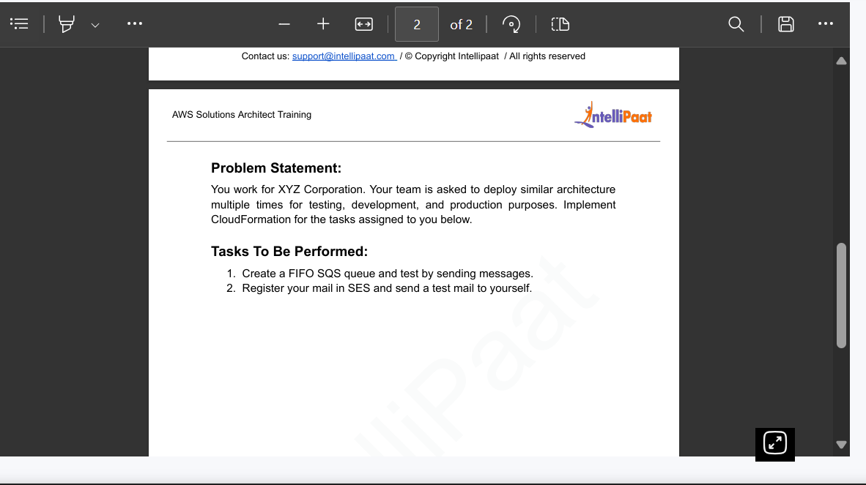

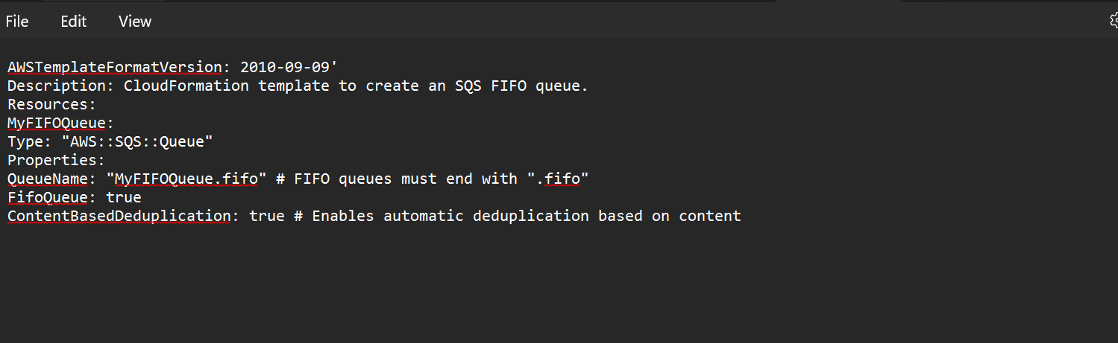

I have converted the file in JSON. Name-modify-.json

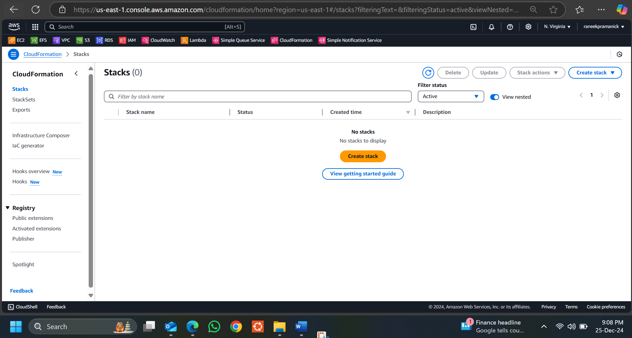

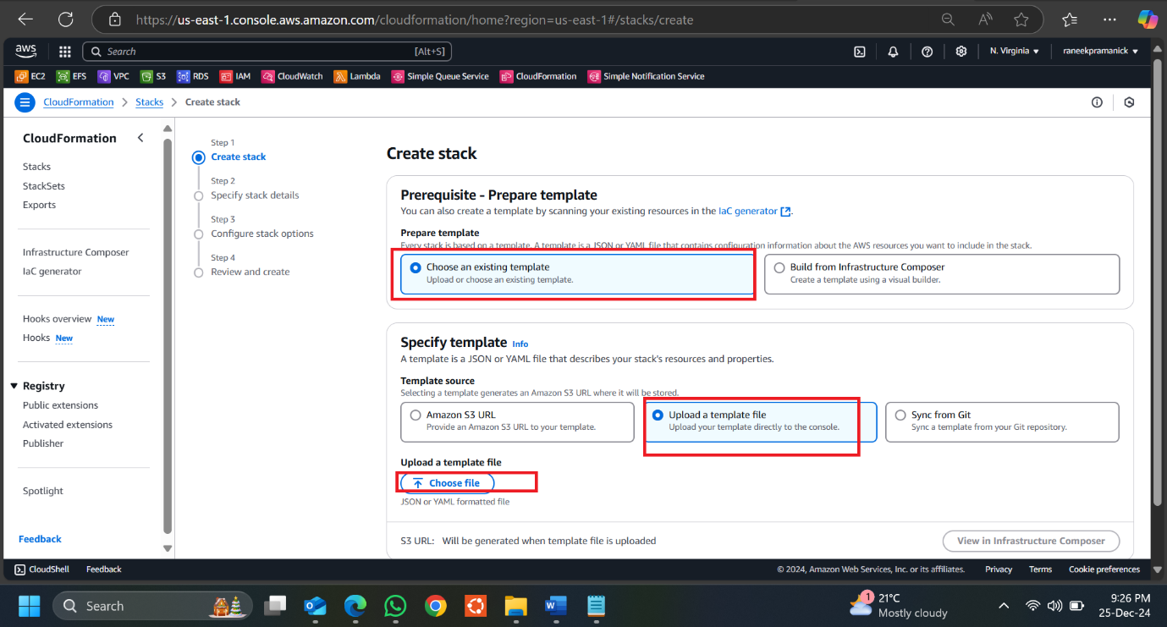

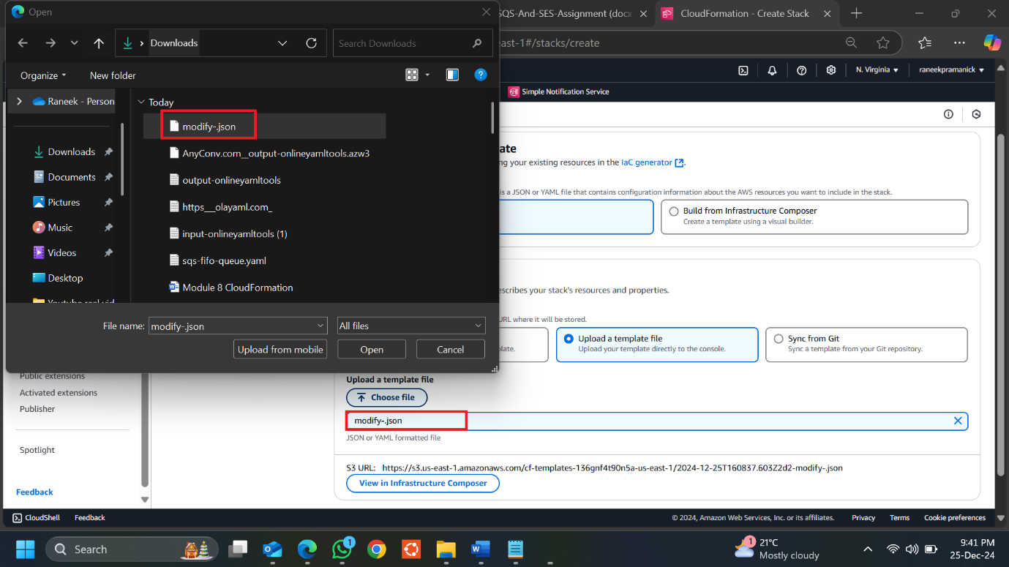

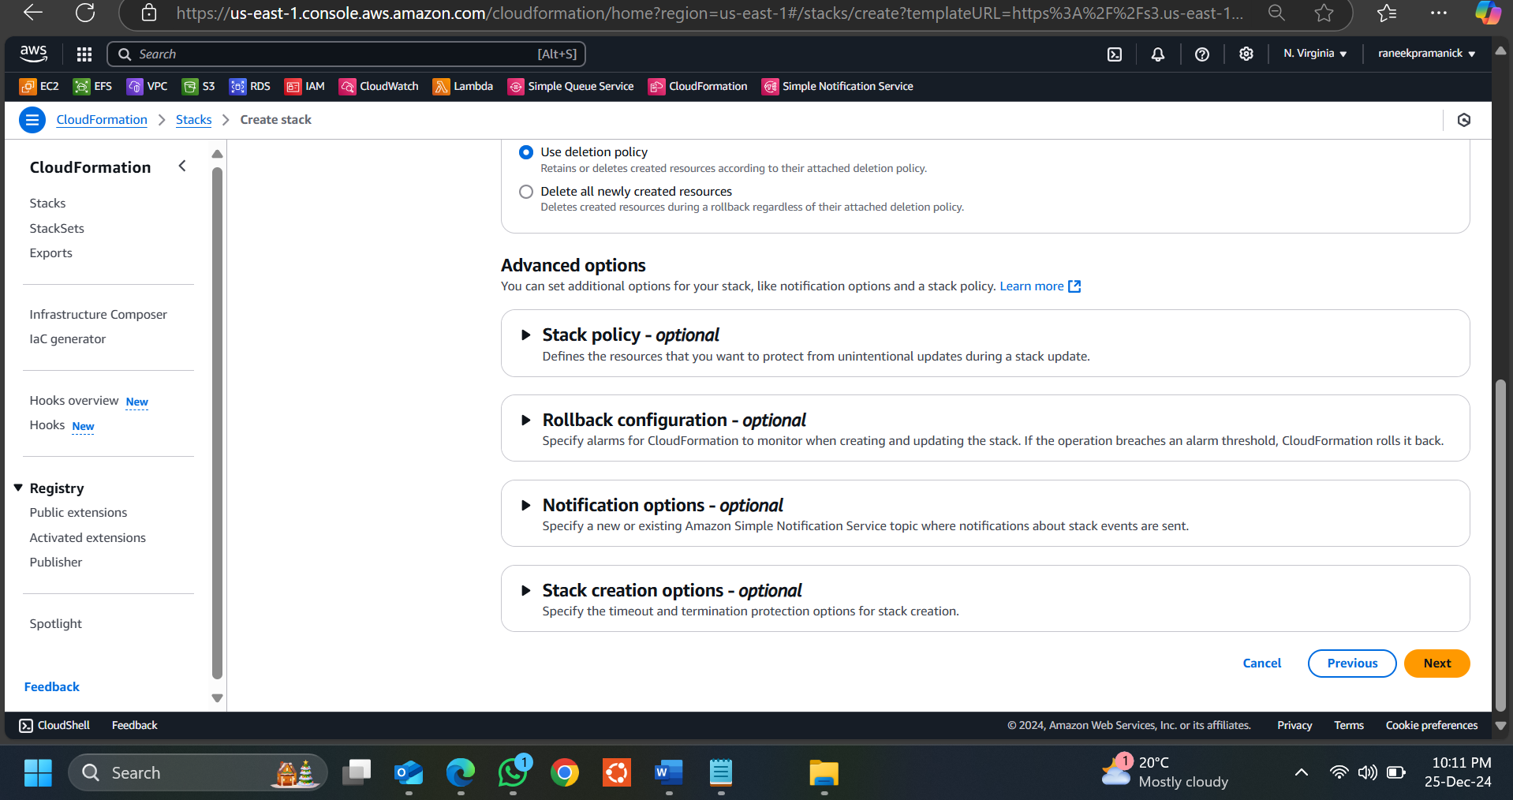

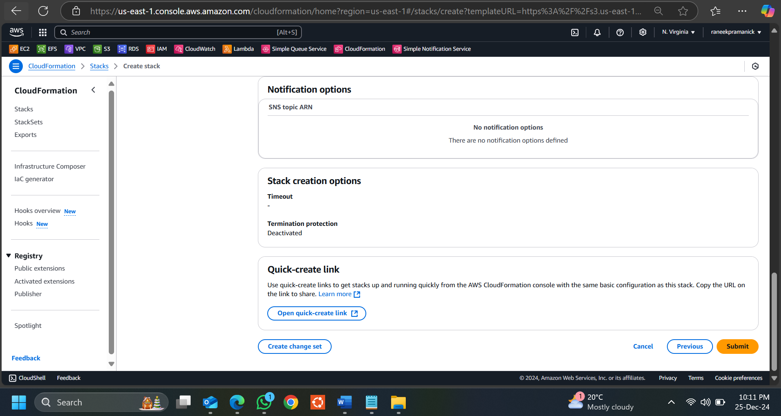

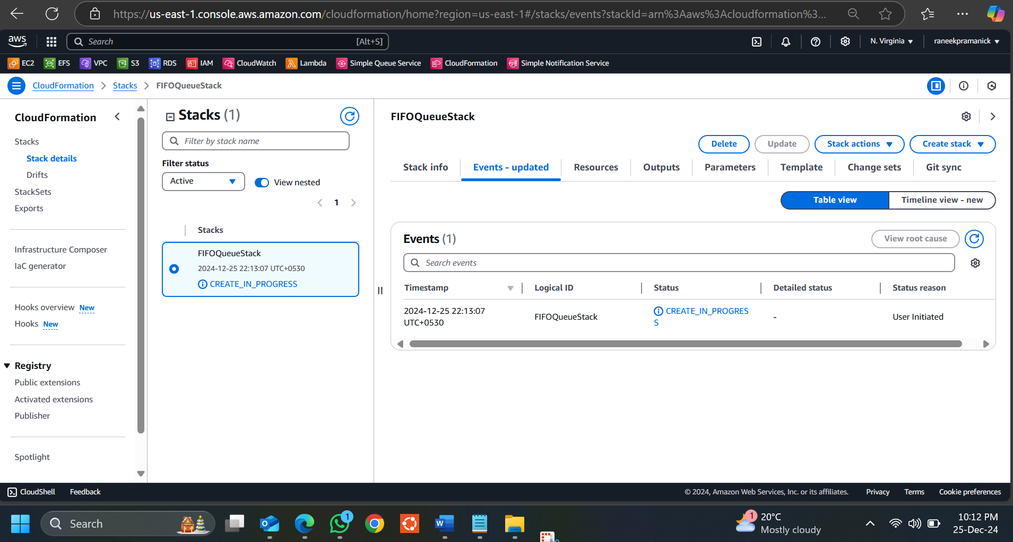

Verify Queue Creation: Once the stack is created, go to the SQS Console in AWS. Verify that there is a new FIFO queue called MyFIFOQueue.fifo in the list of queues.

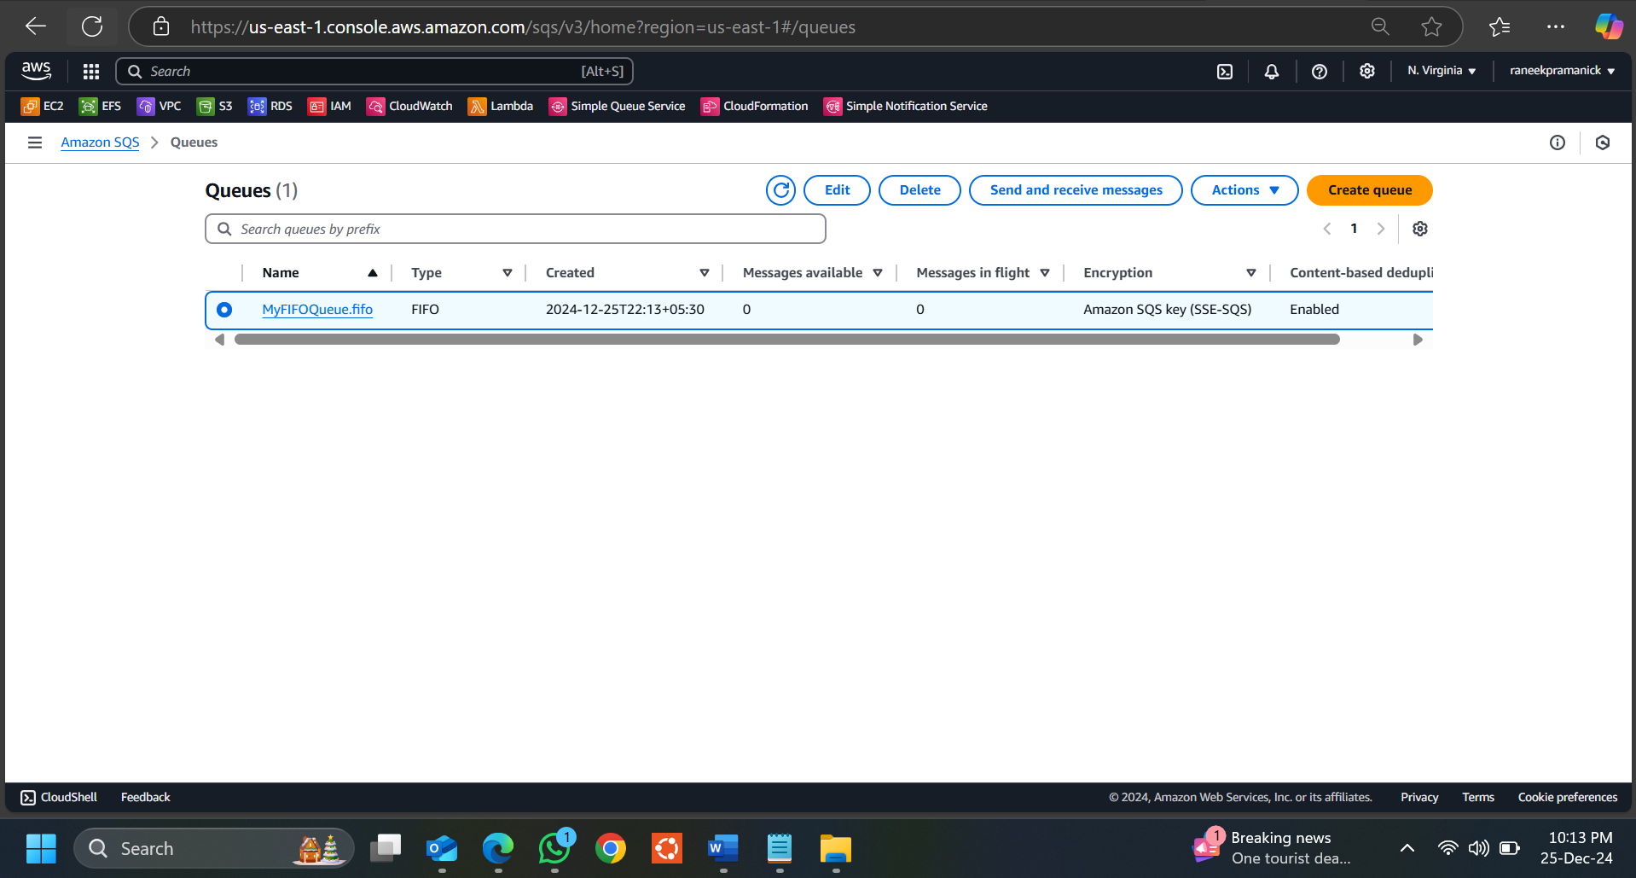

Verify Queue Creation: Once the stack is created, go to the SQS Console in AWS. Verify that there is a new FIFO queue called MyFIFOQueue.fifo in the list of queues. Now go to CloudFormation console verify the stack is created

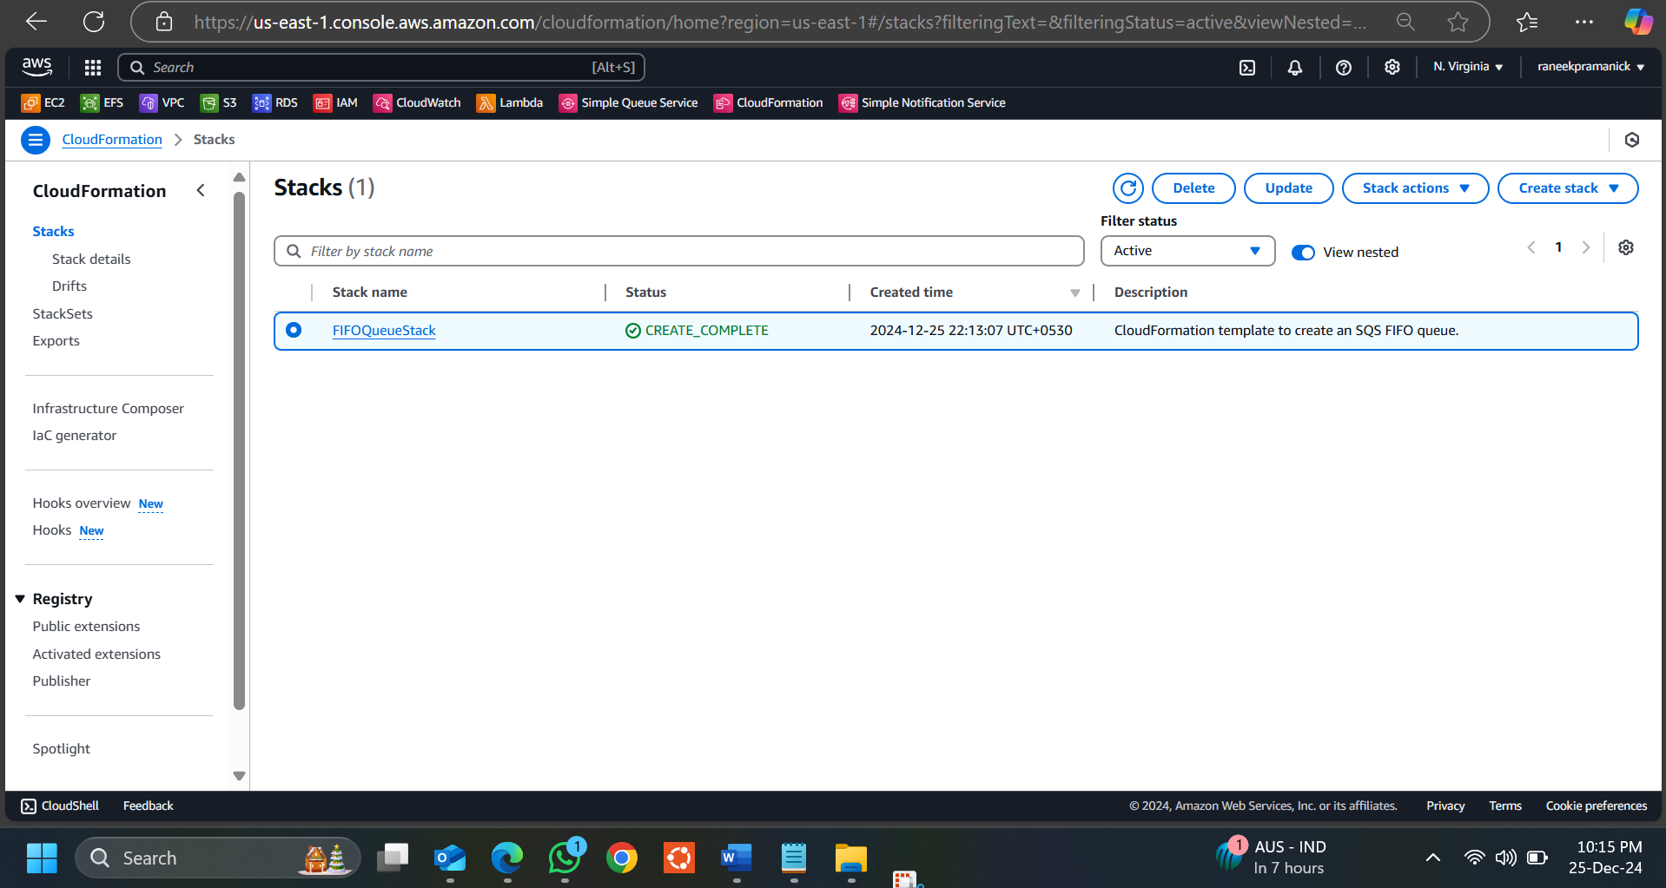

Test the SQS Queue by Sending Messages. Send a Message to the FIFO Queue. In the SQS Console, select MyFIFOQueue.fifo from your list of queues. Click on Send and receive messages.

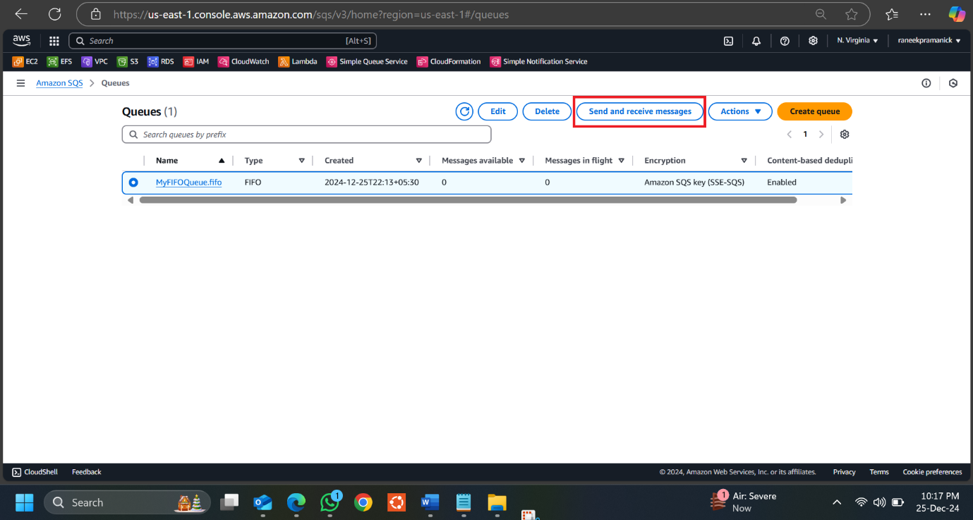

Enter Message Details. In the Message body section, type a sample message like "Test message ". Enter a Message Group ID like "Group - 1". For FIFO queues, Message Group ID is required to ensure the messages are processed in the order they're sent within that group. Click Send message.

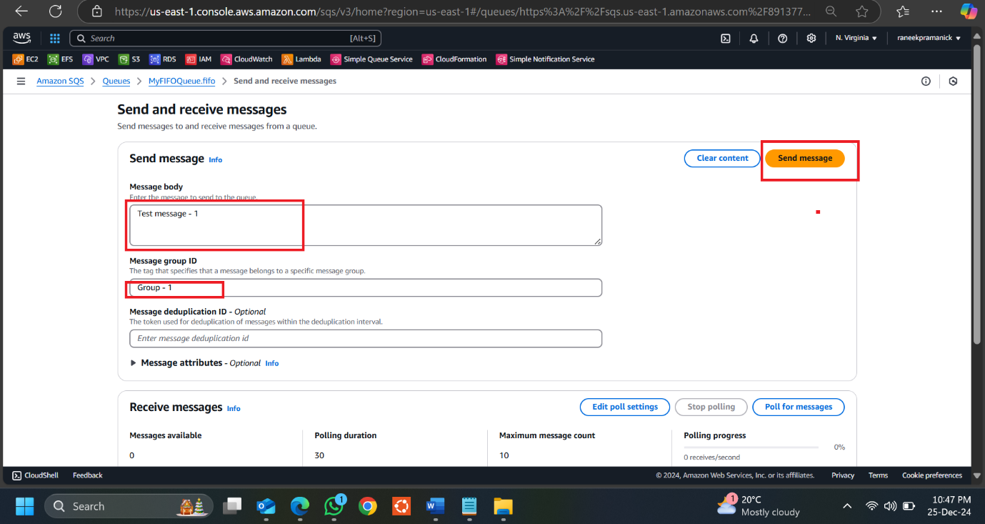

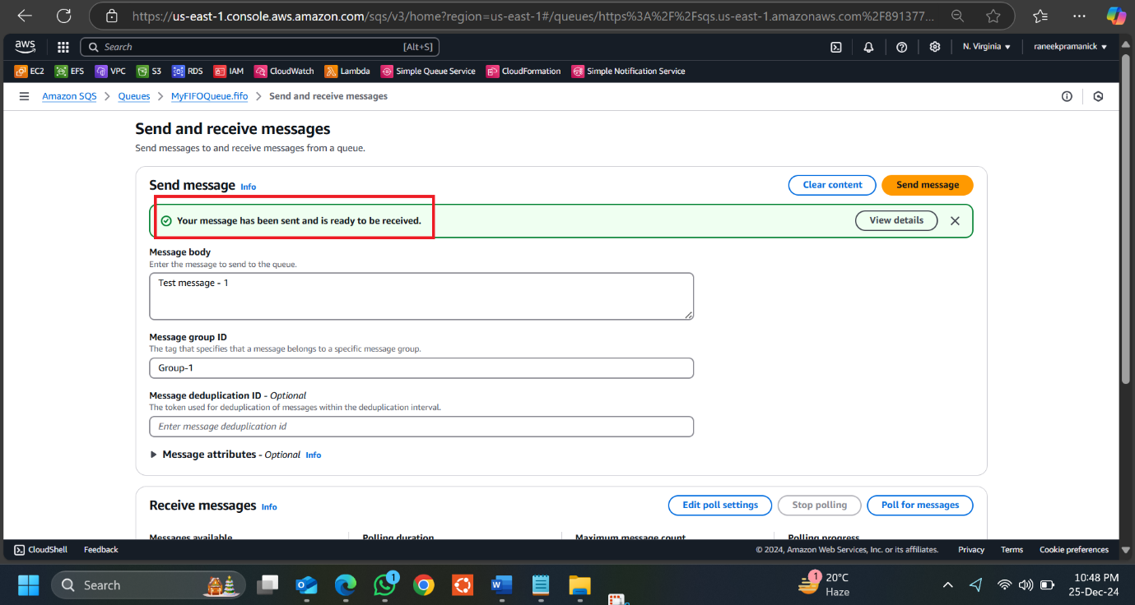

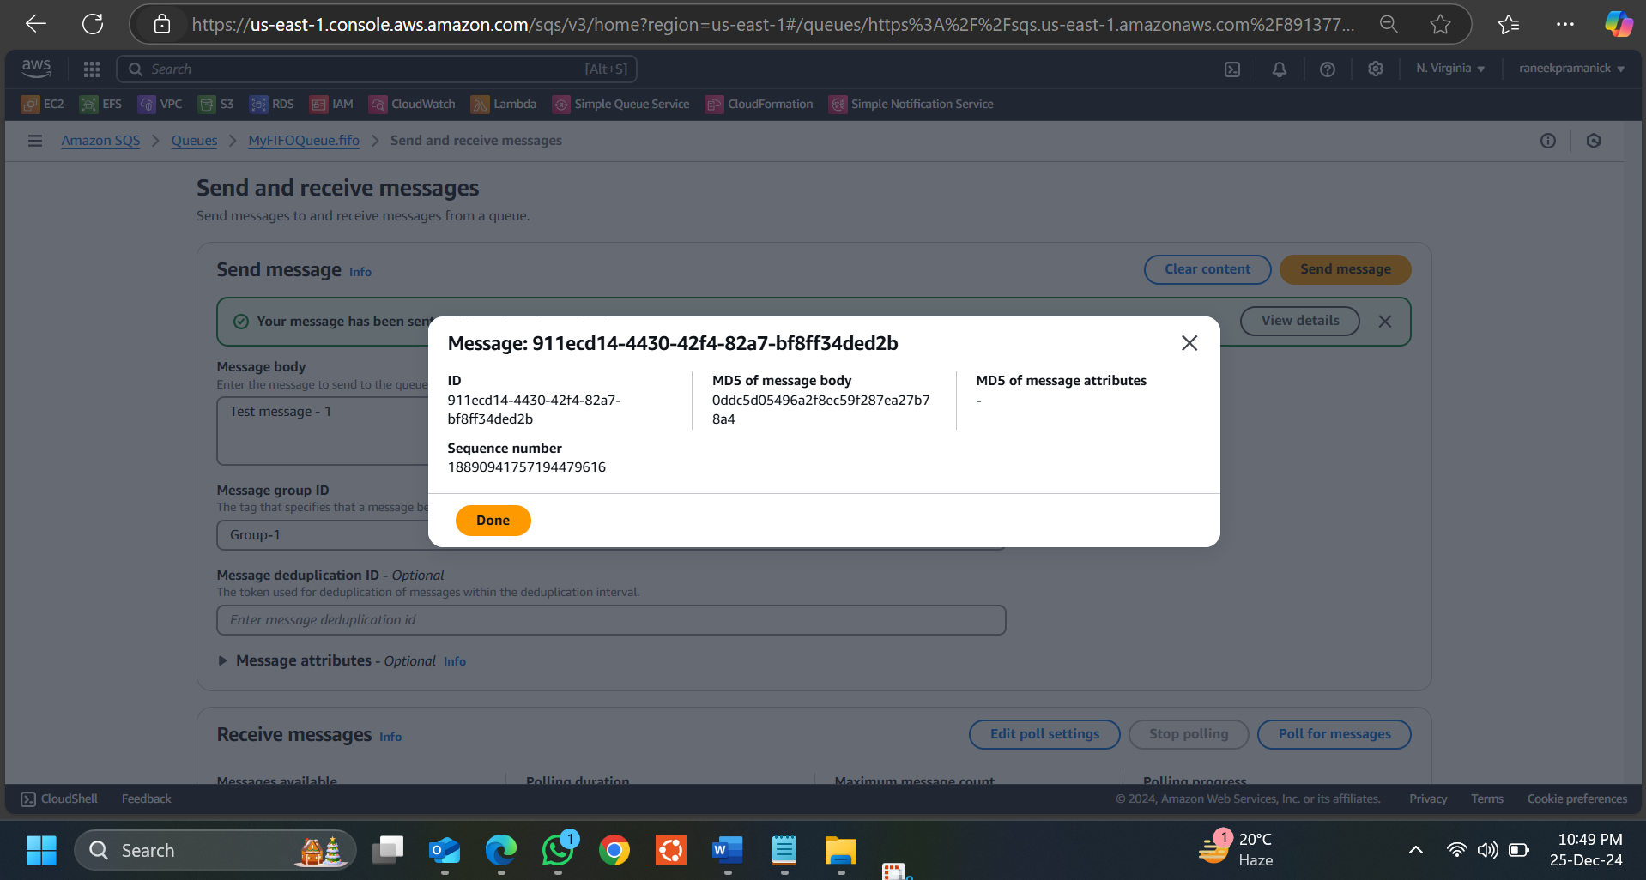

Send Additional Messages for Testing. Send a few more messages, changing the Message body (e.g., "Test message - 2", "Test message - 3") but using the same Message Group ID. This will help demonstrate the FIFO behaviour of the queue when messages are processed.

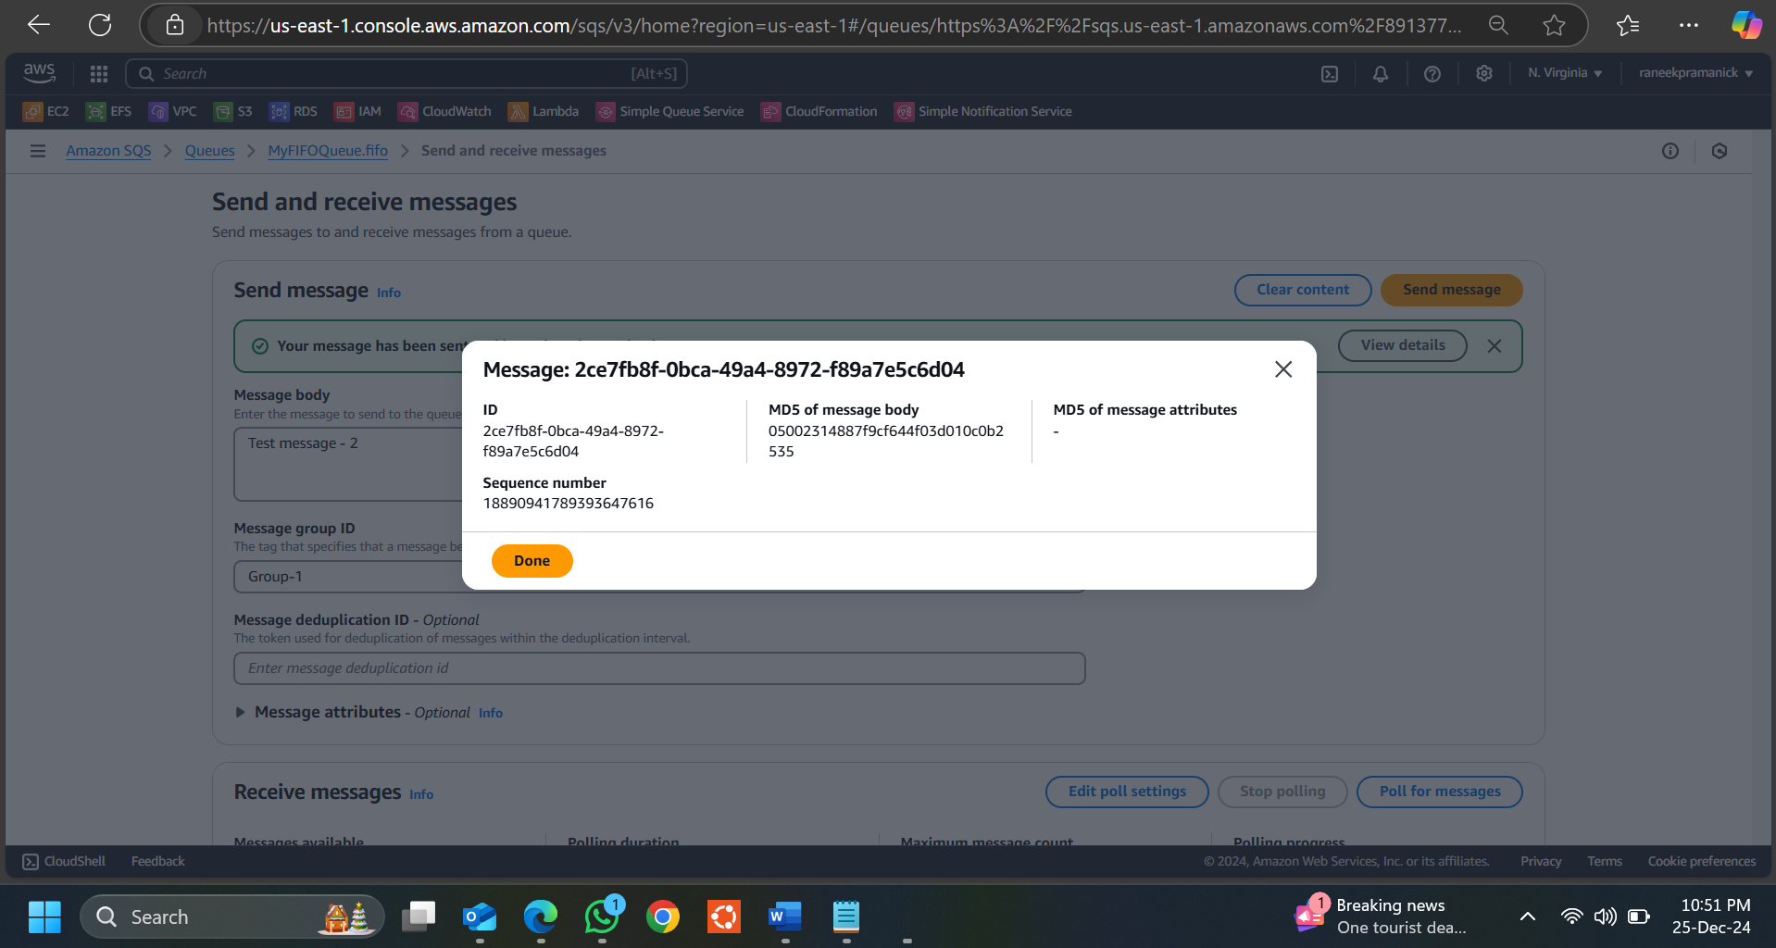

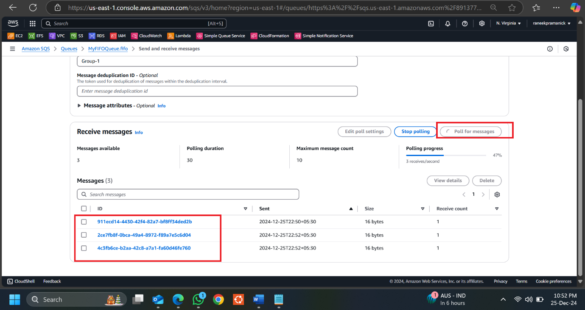

Registering Your Email in Amazon SES and Sending a Test Email.

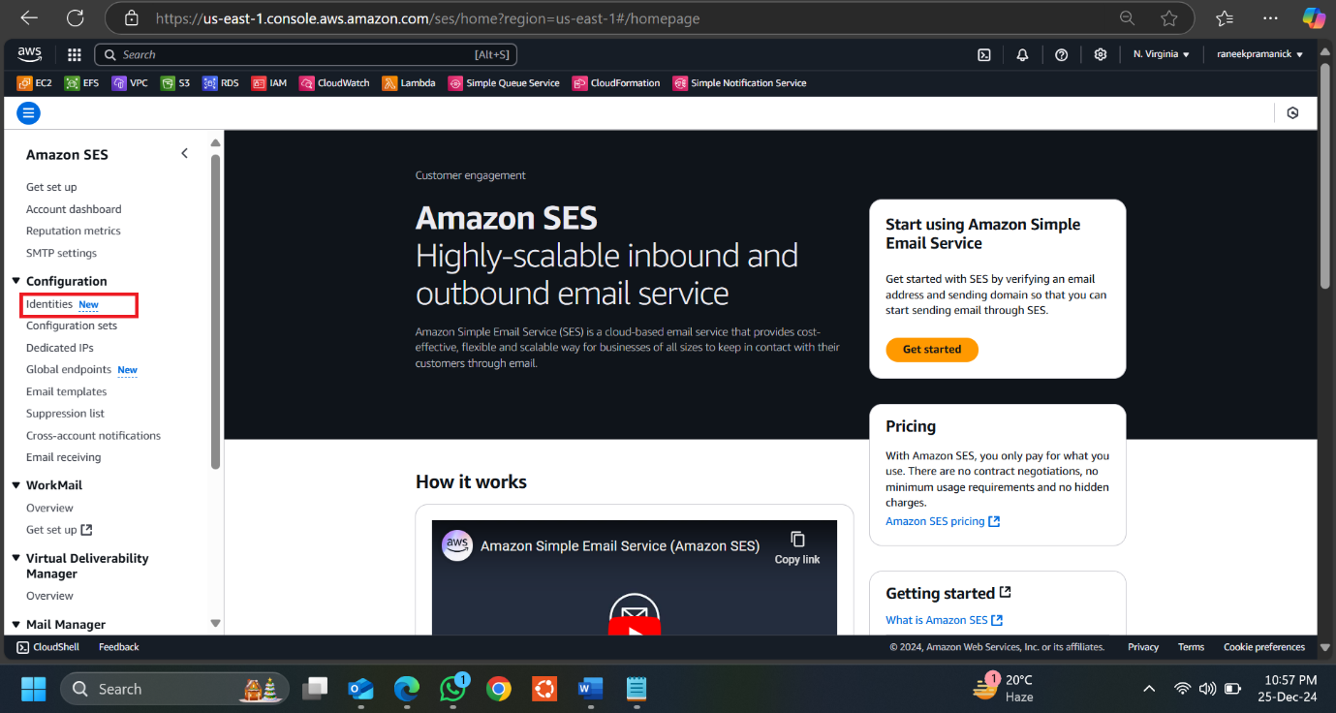

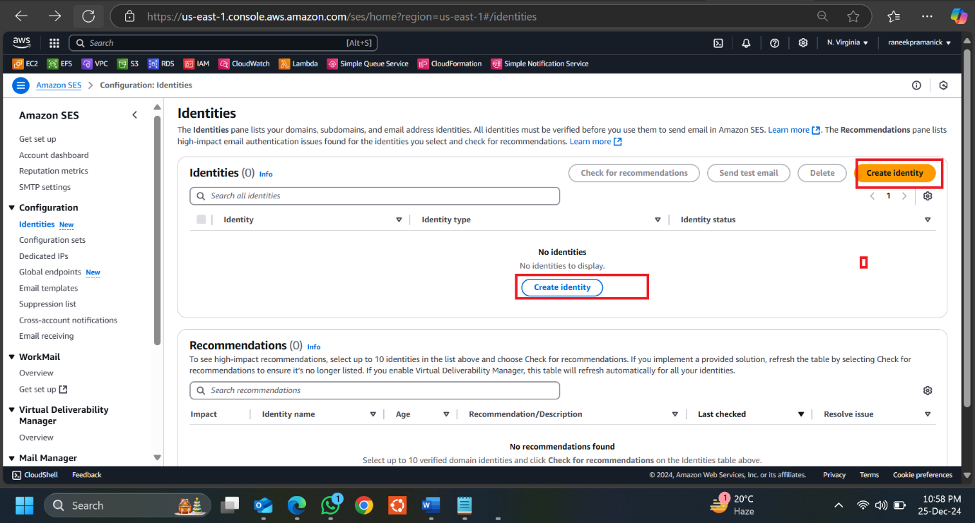

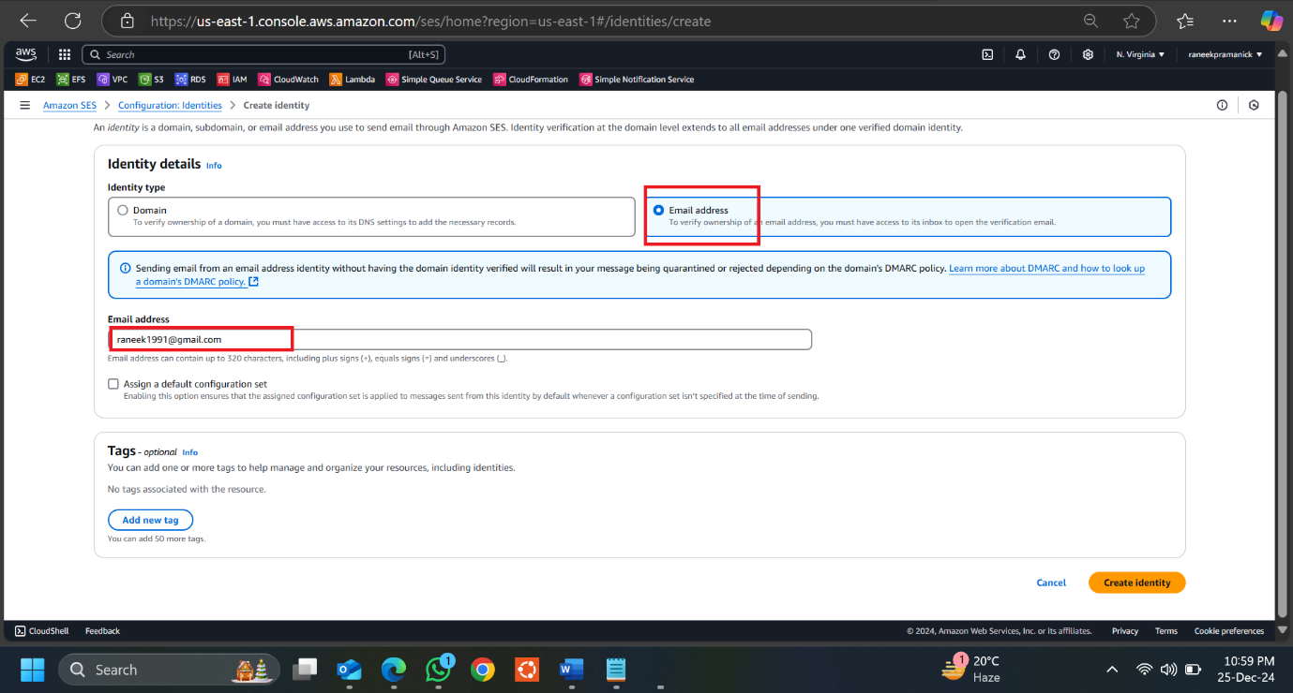

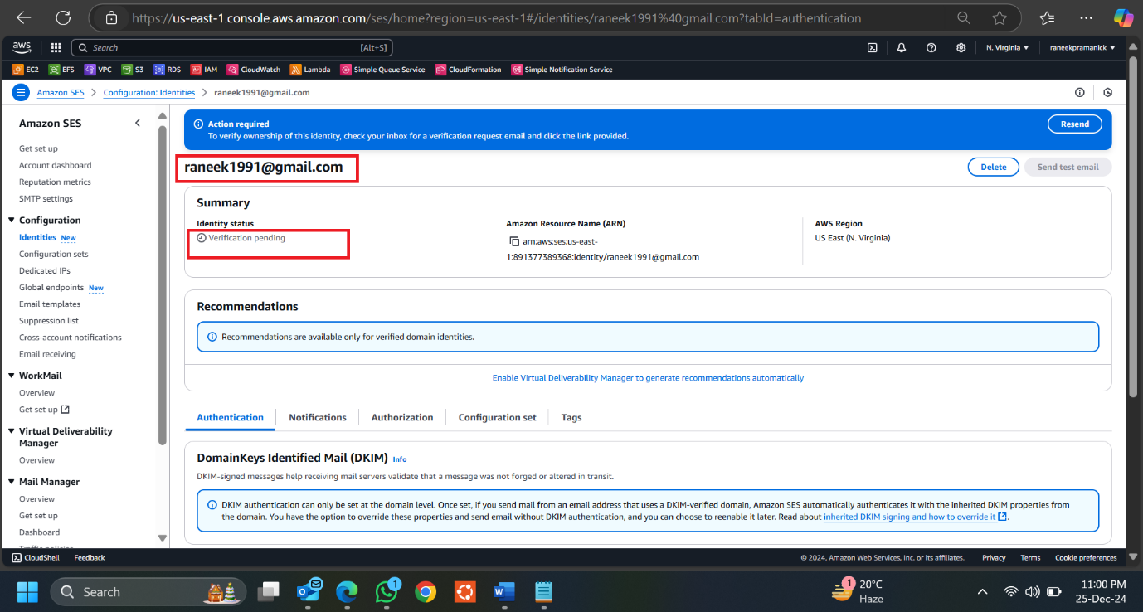

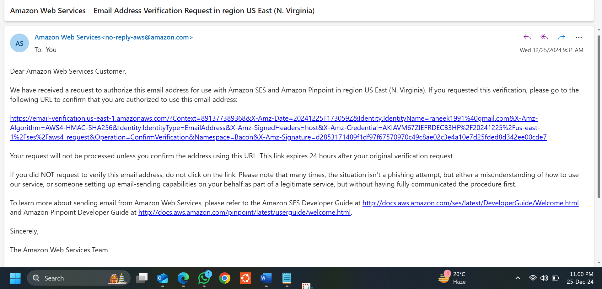

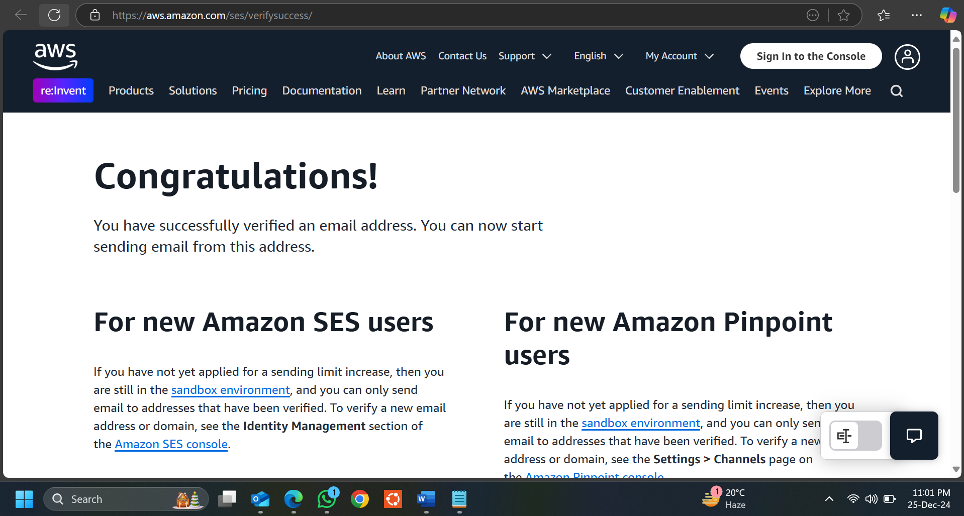

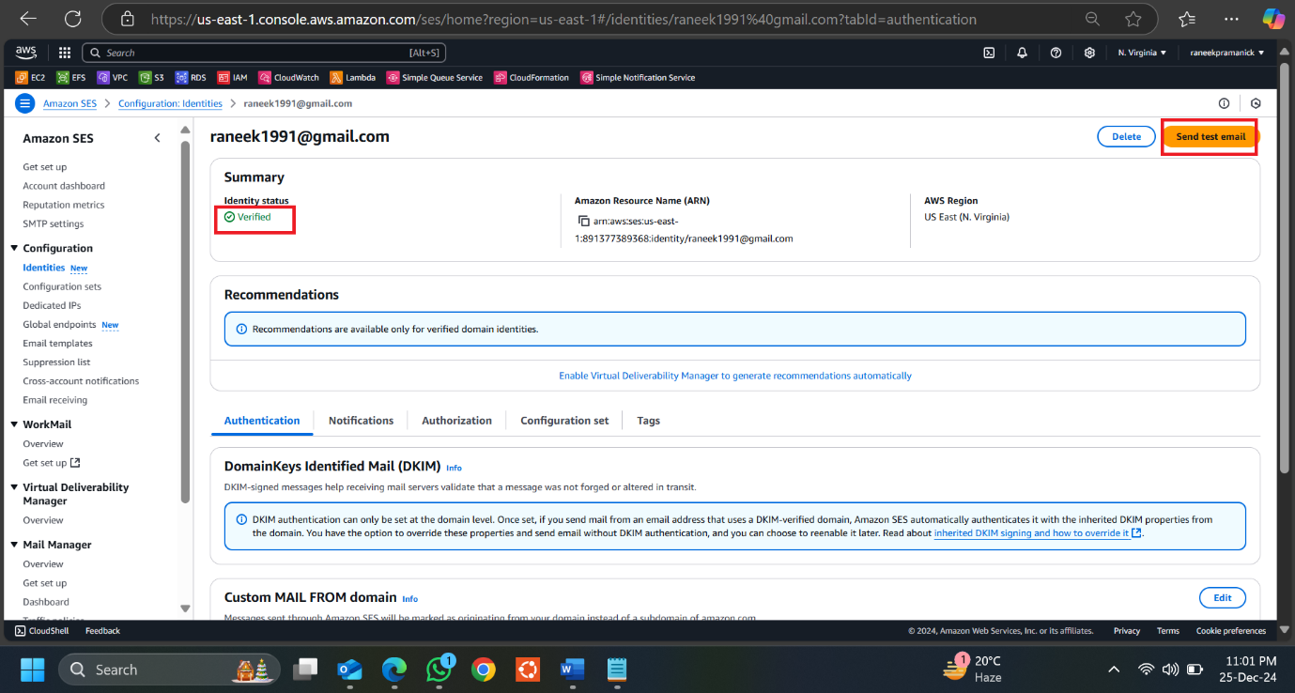

Send a Test Email Using SES.

